Prostate Cancer: Poor Prognosis in Men with Diabetes
Men with type 2 diabetes are less likely to develop prostate cancer than patients without diabetes. However, the mortality rate is higher. Researchers of the German Center for Diabetes Research (DZD) from Tübingen and experts of Helmholtz Zentrum München and the Urology Department of Tübingen University Hospital were able to show that in the affected individuals the androgen receptor and the mitogenic forms of the insulin receptor were more strongly expressed. This could explain why patients with diabetes have a poorer prognosis for prostate cancer. The current results were published in the journals Molecular Metabolism and Endocrine Related Cancer.
Prostate cancer and type 2 diabetes are among the most common diseases in men. Although studies indicate that people with diabetes suffer more frequently from cancer, men with diabetes do not increasingly suffer from prostate cancer. On the contrary, meta-analyses of studies have shown that diabetes patients are less likely to develop this carcinoma. However, the mortality rate is higher. This is also confirmed by current research carried out by researchers at the Institute for Diabetes Research and Metabolic Diseases (IDM) of Helmholtz Zentrum München at the University of Tübingen, a partner of the DZD, in cooperation with the Department of Urology at Tübingen University Hospital. The research team recently analyzed the data of patients who had their prostate removed due to cancer. As expected, among them were fewer patients with diabetes than in the general population. However, prostate cancer patients with diabetes were significantly more likely to have metastases in the lymph nodes. In addition, the proportion of patients who are at very high risk according to the guidelines of the National Comprehensive Cancer Network (NCCN) was significantly higher among those with diabetes.
But how do prostate carcinomas differ in men with and without diabetes? What makes prostate carcinoma in patients with metabolic disease so aggressive? The researchers investigated these questions in another study. For this purpose, they analyzed 70 tumor samples from patients without diabetes and 59 samples from patients with type 2 diabetes.
Since male sex hormones (androgens) play an important role in the development of prostate cancer, the scientists investigated the androgen signaling chain. We conducted a gene expression analysis of key proteins and found that in men with diabetes, the androgen receptor (AR) was increased," said Dr. Martin Heni, who led the study at the IDM. The signaling pathway mediated by AR was also more strongly activated.
The scientists identified another difference: "Insulin receptors of isoform A are increasingly expressed in the prostate carcinomas of patients with diabetes," said Dr. Stefan Lutz, first author of the study. These can bind insulin-like growth factors (IGFs). This contributes to increased cell growth and cell division. Normally, adults mainly express the isoform B, which does not bind IGF.
In addition, in patients with diabetes, the steroid biosynthesis in the tumor is also altered. Less protective estrogen receptor ligands are formed. This further strengthens the androgen signaling pathway in tumors.
Our research provides new insights into why prostate cancer is so aggressive in men with type 2 diabetes," said Dr. Heni, summarizing the results. Prostate carcinoma in men with type 2 diabetes has a poorer prognosis and must therefore be diagnosed and treated earlier and more comprehensively than prostate cancer in nondiabetics," said Professor Arnulf Stenzl, MD, head physician of the Urology Department of Tübingen University Hospital.

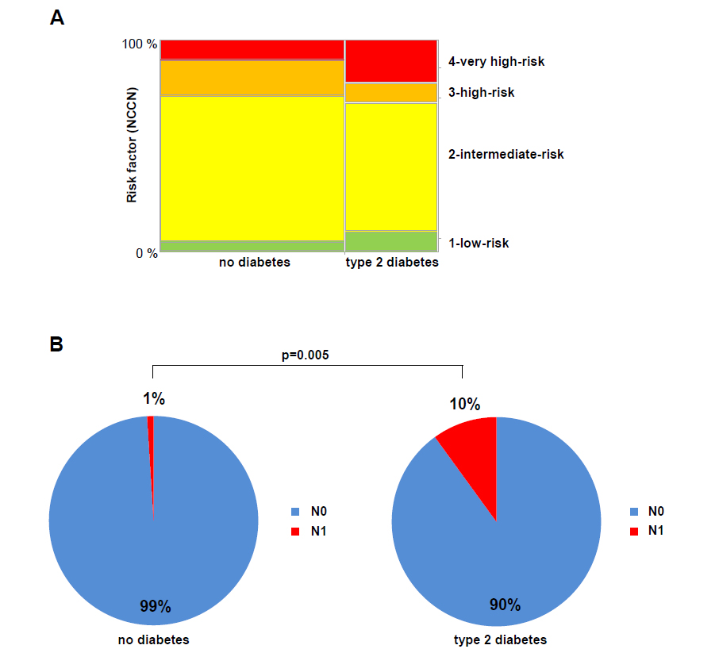

A: The risk score of the National Comprehensive Cancer Network (NCCN) was calculated for each of the 74 patients with type 2 diabetes and the 148 men without diabetes. The relative distribution is shown in the figure.
B: Prevalence of lymph node metastases in patients with and without type 2 diabetes. The relative prevalence of lymph node metastases is shown at the time of radical prostatectomy in 74 patients with type 2 diabetes and 148 men without diabetes.

Original Publications:
Lutz, S Z et al. (2017): Androgen receptor overexpression in prostate cancer in type 2 diabetes. Molecular Metabolism, DOI: https://doi.org/10.1016/j.molmet.2017.11.013

Lutz, S Z et al. (2018): Higher prevalence of lymph node metastasis in prostate cancer in patients with diabetes. Endocr Relat Cancer. doi: 10.1530/ERC-17-0465. [Epub ahead of print]

Scientific Contact:
Assistant Professor Martin Heni; MD
Institute for Diabetes Research and Metabolic Diseases (IDM) of Helmholtz Zentrum München at the University of Tübingen
Otfried-Müller-Str. 10
72076 Tübingen
email: Martin.Heni@med.uni-tuebingen.de

Media Contact:
Birgit Niesing
German Center for Diabetes Research (DZD)
Ingolstädter Landstr. 1
85764 Neuherberg
Germany
Phone: +49 (0)89-3187-3971
email: niesing@dzd-ev.de

The German Center for Diabetes Research (DZD) is one of six German Centers of Health Research. It brings together experts in the field of diabetes research and combines basic research, epidemiology and clinical applications. By adopting an innovative, integrative approach to research, the DZD aims to make a substantial contribution to the successful, personalized prevention, diagnosis and treatment of diabetes mellitus. The members of the association are Helmholtz Zentrum München – German Research Center for Environmental Health, the German Diabetes Center (DDZ) in Düsseldorf, the German Institute of Human Nutrition in Potsdam-Rehbrücke (DIfE), the Institute of Diabetes Research and Metabolic Diseases of Helmholtz Zentrum München at the University of Tübingen, and the Paul Langerhans Institute Dresden of Helmholtz Zentrum München at the University Medical Center Carl Gustav Carus of TU Dresden, associated partners at the universities in Heidelberg, Cologne, Leipzig, Lübeck and Munich, and other project partners. Further information: www.dzd-ev.de/en
As German Center for Environmental Health, Helmholtz Zentrum München pursues the goal of developing personalized medical approaches for the diagnosis, therapy and prevention of major common diseases such as diabetes mellitus and lung diseases. To achieve this, it investigates the interaction of genetics, environmental factors and lifestyle. The head office of the center is located in Neuherberg to the north of Munich. Helmholtz Zentrum München has approximately 2300 staff members and is a member of the Helmholtz Association, a German research organization comprised of 18 scientific-technical and medical-biological research centers with a total of about 37,000 staff members. www.helmholtz-muenchen.de/en
Founded in 1805, Tübingen University Hospital is one of the leading centers of German university medicine. As one of the 33 university hospitals in Germany, it contributes to the successful combination of high-performance medicine, research and teaching. Every year, more than 400,000 patients from all over the world are treated on an inpatient or outpatient basis and benefit from this combination of science and practice. The clinics, institutes and centers unite all specialists under one roof. The experts work together across disciplines and offer each patient optimal treatment based on the latest research results. Tübingen University Hospital conducts research to achieve better diagnoses, therapies and chances of recovery; many new treatment methods are being clinically tested and applied here. Neurosciences, oncology and immunology, infection research and vascular medicine along with diabetes research are the focal points of research in Tübingen. The University Hospital is a reliable partner in four of the six German Centers for Health Research initiated by the Federal Government.

